**Data Science – Report Task 1**

**Task -** Descriptive Statistics and Data Profiling

Analyse a small dataset (e.g., student scores, product reviews) and provide summary statistics (mean, median, mode, etc.) and insights.

**Summary -** The project involves analysing a dataset titled "CAR DETAILS FROM CAR DEKHO.csv" to perform descriptive statistics and data profiling. Using Python libraries such as Pandas, NumPy, and Matplotlib, the data is explored to compute summary statistics like mean, median, and mode for key attributes, including the year of manufacture, selling price, kilometres driven, and fuel type. The notebook organizes this information into a dictionary for easy reference, highlighting trends in both numerical and categorical data. This approach provides insights into the dataset's structure and characteristics, forming the basis for deeper analysis or visualization.

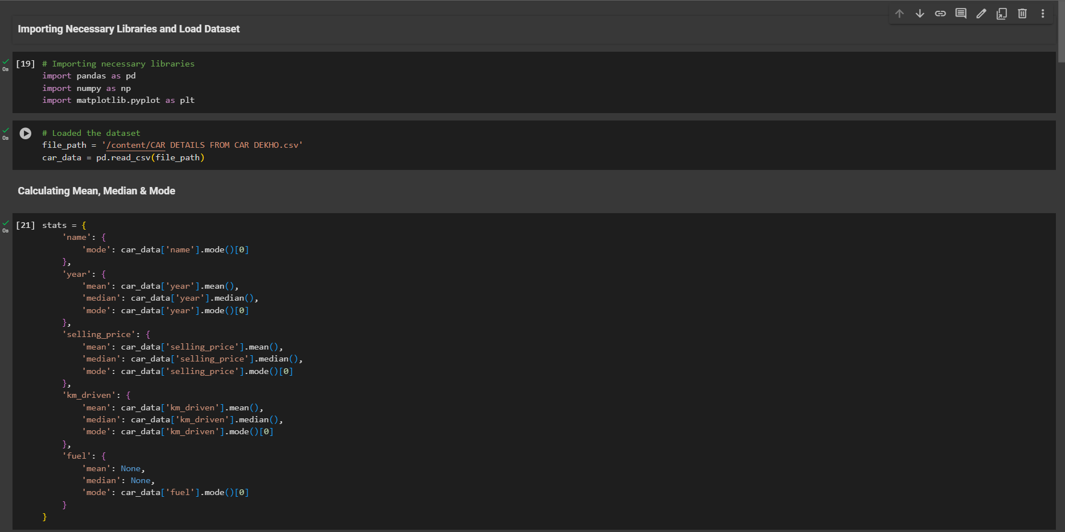

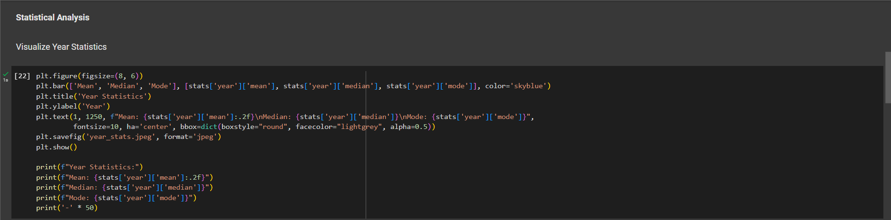

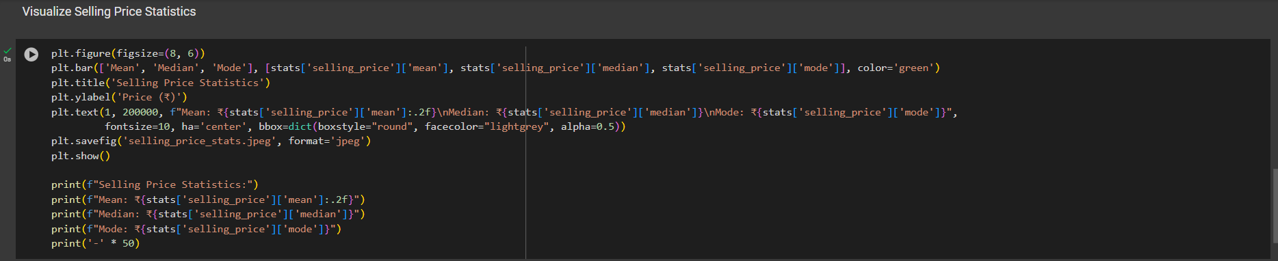

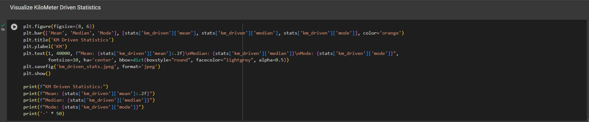

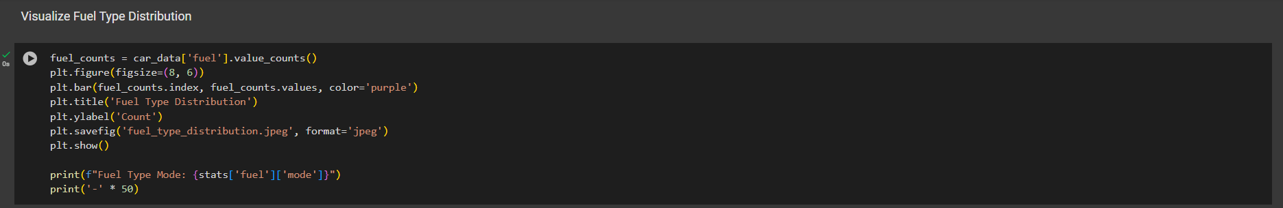

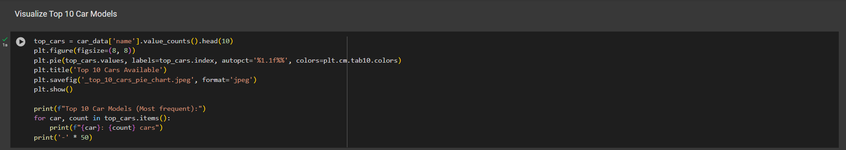

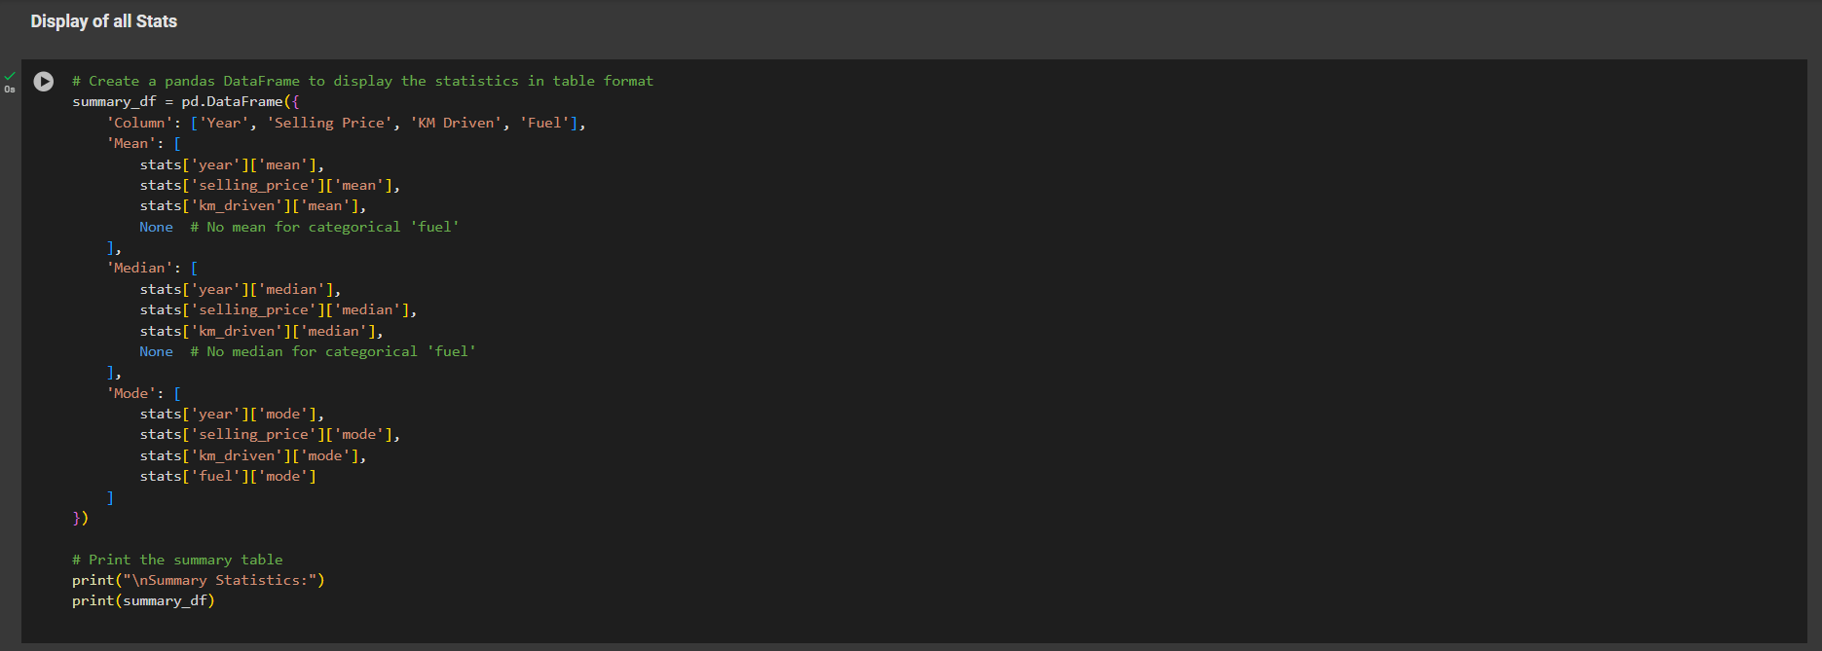

**Output –**

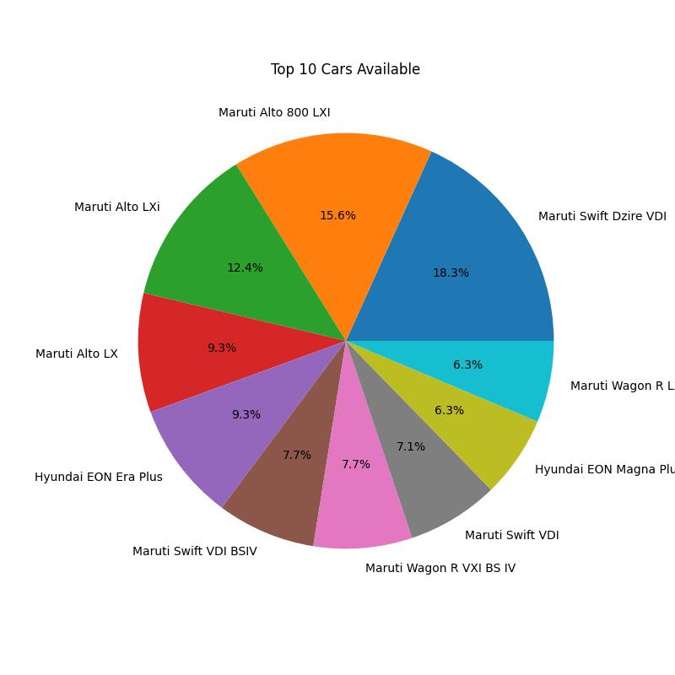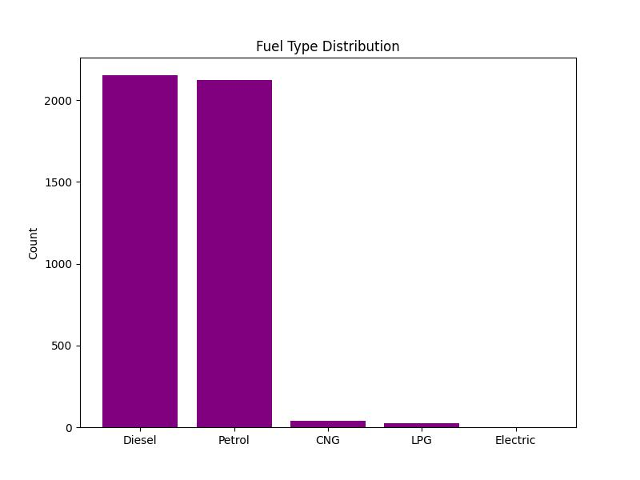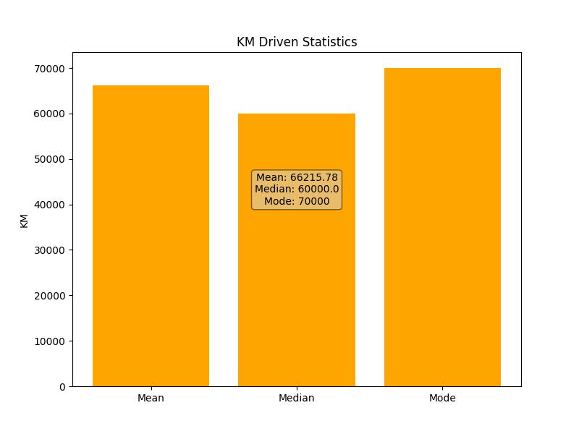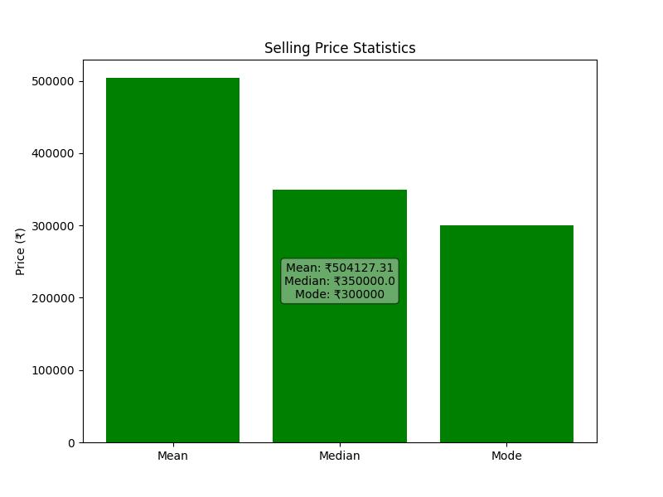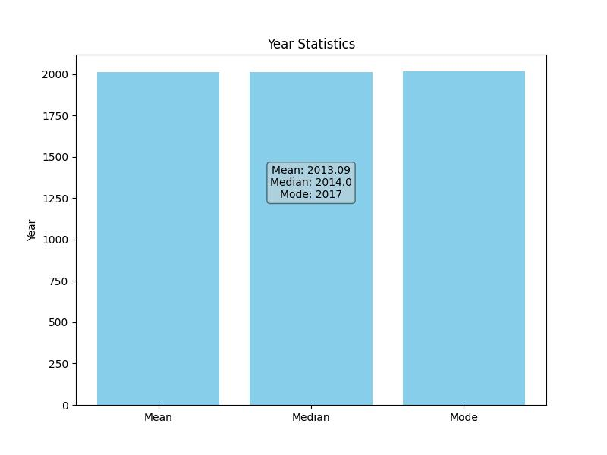

**Skills Learned -**  Data exploration, statistics.

**Tools -** Python (Pandas, Numpy, Matplotlib).

**Conclusion** **-** In conclusion, the analysis provided key insights into the dataset by calculating summary statistics like mean, median, and mode for important attributes. This profiling highlights trends such as average car prices, popular models, and fuel types, offering a clear understanding of the data. These insights serve as a solid foundation for further analysis or decision-making.